Experimental Design – Design Components (drop-in)
To test whether internal timing policies can deliver management’s targets, we ran a 2³ factorial design in Vensim on the three aging-chain time constants. Factors and levels: learning time x1 = 1 vs. 2 years; maturing time x2 = 3 vs. 5 years; retiring (Gray-Hair tenure) time x3 = 10 vs. 15 years. All runs use the stepped hiring profile (50/year in year 1, then a constant rate solved per combination as described below).

Table 1 – Hiring solved for 7.8M lamps/year (base productivity)
In each combination the hiring rate after year 1 was solved so the model produces exactly 7.8 million lamps/year at current productivity. Production is therefore fixed by construction in every row – the meaningful response is the workforce each combination needs. Every combination overshoots the 1,700-employee target; combination 2 (1, 3, 15) needs the fewest.
Combo | x1 learn (yr) | x2 mature (yr) | x3 retire (yr) | Hiring/yr after yr 1 | Employees yr 10 | Production yr 10 (M)
1 | 1.0 | 3.0 | 10.0 | 283.65 | 2565 | 7.8
2 | 1.0 | 3.0 | 15.0 | 244.59 | 2482 | 7.8
3 | 1.0 | 5.0 | 10.0 | 293.88 | 2784 | 7.8
4 | 1.0 | 5.0 | 15.0 | 258.52 | 2687 | 7.8
5 | 2.0 | 3.0 | 10.0 | 303.58 | 2810 | 7.8
6 | 2.0 | 3.0 | 15.0 | 264.48 | 2701 | 7.8
7 | 2.0 | 5.0 | 10.0 | 315.45 | 3030 | 7.8
8 | 2.0 | 5.0 | 15.0 | 279.88 | 2912 | 7.8
Figure 1 – Workforce needed per combination to reach 7.8M lamps (combo 2 highlighted).
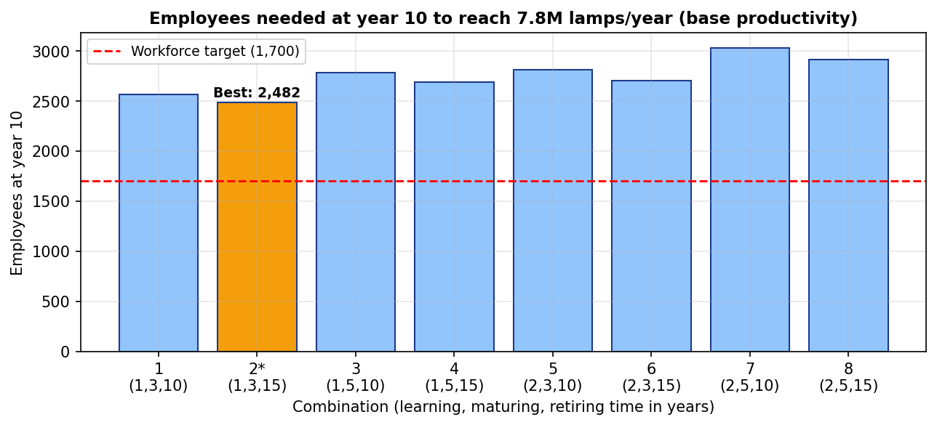

Table 2 – Hiring solved for 1,700 employees; productivity gain still required
Here the hiring rate after year 1 was solved so each combination lands on exactly 1,700 employees at year 10. The table shows the resulting base-production and the productivity gain still needed to reach 7.8M lamps. Combination 2 again dominates: it needs the smallest gain (+41.7%).
Combo | x1 (yr) | x2 (yr) | x3 (yr) | Hiring/yr for 1,700 | Base prod. (M) | Gain needed
1 | 1.0 | 3.0 | 10.0 | 170.5 | 5.31 | 47.0%
2 | 1.0 | 3.0 | 15.0 | 147.3 | 5.51 | 41.7%
3 | 1.0 | 5.0 | 10.0 | 158.4 | 4.95 | 57.7%
4 | 1.0 | 5.0 | 15.0 | 139.4 | 5.15 | 51.3%
5 | 2.0 | 3.0 | 10.0 | 163.5 | 4.93 | 58.4%
6 | 2.0 | 3.0 | 15.0 | 142.9 | 5.15 | 51.3%
7 | 2.0 | 5.0 | 10.0 | 153.5 | 4.63 | 68.5%
8 | 2.0 | 5.0 | 15.0 | 136.3 | 4.86 | 60.6%

Recommended policy trajectory (combination 2)
Combination 2 (1-yr learning, 3-yr maturing, 15-yr retiring) with ≈147 hires/year after year 1 reaches 1,700 employees and 5.51M lamps at base productivity; a 41.7% productivity gain (technology, methods, automation) closes the gap to 7.8M.
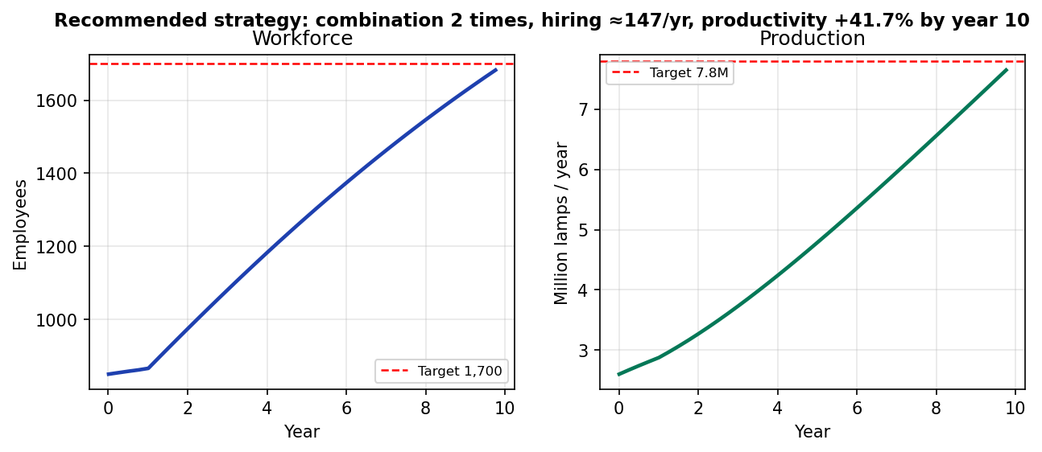

Analysis notes (for the results discussion)
- Combination 2 is the best timing configuration: fewest employees to hit 7.8M at base productivity (2,482), and the smallest required productivity gain (+41.7%) under the 1,700 headcount.
- Retiring time (x3) has the highest leverage of the three factors: extending Gray-Hair tenure from 10 to 15 years adds ≈210K lamps/year on average across the design (holding headcount at 1,700), because it keeps the most productive tier (4,000 lamps/yr) in the workforce longer.
- The structural gap persists under every timing combination: even the best case peaks at 5.51M lamps at base productivity, so a productivity intervention is mathematically necessary – no timing policy alone reaches 7.8M with 1,700 employees.

